Rail Commute Using Android Based Device
Snigdha Chaudhuri^{#1} ,Kanchan Jadhav^{#2} ,Ankita Patil^{#3} ,Anjali Takrani^{#4}, Aparna Hajare^{#5}
Student, Computer Dept., CCOEW, Savitribai Phule Pune University, India
Student, Computer Dept., CCOEW, Savitribai Phule Pune University, India
Student, Computer Dept., CCOEW, Savitribai Phule Pune University, India
Student, Computer Dept., CCOEW, Savitribai Phule Pune University, India
Prof, Computer Dept., CCOEW, Savitribai Phule Pune University, India

¹ snigdha0602@live.in
² kjadhav07.kj@gmail.com
³ ankitasharadpatil@gmail.com
⁴ anjalitakrani2008@gmail.com

Abstract— So many people travel daily in train and come across so many railway station and platforms. There is always a problem in locating a book stall, canteen, bathroom, waiting room etc. on unknown station/platform. So we wish to build an android application which will inform you about the next coming station and what is the layout of the station, like how many platforms, where is police station on map/own display. This will help user to get to know the next station before reaching the station and help to locate whatever we need on that station.
This application is basically to serve the people travelling by train and making their journey less complicated.

Keywords— Mobile phones, Station layout, Accelerometer, Road anomalies.
- Introduction

Indian Railways is the principle mode of transport in the country. It is one of the world’s largest rail networks under a single management. The route length is around 63,332km[10] with more than 8000 stations[10]. As it is the backbone of nation’s transport system, IR owns more than 25,000 wagons[10], 45000[10] different types of coaches and 8000 locomotives[10]. The system carries about 5,000 million [10] passengers generating a traffic output of 340 billion [10] passenger kms.
So many people travel daily in train and come across so many railway station and platforms. There is always a problem in locating a bookstall, canteen, bathroom, waiting room etc. on unknown station or platform. So we wish to build and android application which will inform you about the next coming station and the layout of the same, for instance number of platforms, location of the police station on map/ own display. This will help the user to get to know the next upcoming station and help to locate whatever we need on that station. Another important feature included in this application is the time taken by each train on the platform.
The scope doesn’t involve the out of station information except for the tourist places. Application facilitates booking of cabs and rickshaws, booking of lockers on the platforms.
People often miss the announcements on the platforms and tend to miss their trains not knowing the halt time of the train. Application gives us this opportunity to receive the latest announcement and know the halt time. In rail commute system user can search all information about train, station, route, time required to reaching to destination. Apart from this through our system passenger access information like nearest tourist places, passenger can view the whole platform wise layout of a particular station. Passenger can set a reminder of the particular station, which when arrives, the application will send an alert sound or vibrate. Also The passenger will be able to view the amount of time the train is going to wait at the particular station. Passenger can post complaints about the services in the train. The passenger can receive alerts and alarms for protection against thefts to take. The main aim of the project was to develop a application which would facilitate to access information about train, station layout, nearest tourist places etc through an effective and yet simple GUI for a normal passenger intending to travel in railways. Consequently, the higher number of passenger uses the train to travel from source to destination. so we proposed a system railway guide.

- Existing Applications
- Indian Rail Guide Application
Indian Rail Guide is a complete travel companion application for the frequent travellers of Indian railways. With Indian Rail Guide, you can access train ticket status, train timetable, train live running information, train seat availability , train fare, train arrivals/departure at a station and much more from your mobile.
Limitation: Only static information is provided.
- IndRail Indian Railway Application
Using IndRail you can get information about Indian railway(s) such as current PNR status, seat availability, fare enquiry, train routes, and information of any train.
Limitation: Only static information is provided.
- Indian Rail Train, IRCTC Info
Indian Rail Train, IRCTC Info App is developed to easily access information regarding indian rail way reservation.
Limitations: Very Less features
- Proposed work

By our proposed system we try to present an easy remedy for uprooting some of the above drawbacks of the previous systems. Our effort is to introduce a widely used, user friendly application which helps make travelling by railways easier.
- System Overview
Proposed application requires internet connection and GPS at all times during the travel by railways. This application is specifically designed to meet the limitations of day to day travel by railways and hence is for the people travelling by train. This application covers various modules as described below:

Passenger Module
The passenger can register to use the app creating id, password. The passenger can login to the system with its own id and password created at the time of registration. The passenger will be receiving the notification of arrival of the next station. The passenger can view the whole platform wise layout of a particular station. The passenger can set a reminder of the particular station, which when arrives, the application will send an alert sound or vibrate. The passenger will be able to view the amount of time the train is going to wait at the particular station. The passenger’s location is sent to the people he/she is going to visit.
Station Master
The station master can login to his account of his station. The station master can feed in data of his station. The station master can send important notification to the passenger on the station. If baggage is reported lost the immediately notify the station staff and the other station masters, where ever the train is going to stop.
Station layout module
End user can search for next coming station and can see the layout of next station. It check all shops, tea stall, hotel on the coming station, number of platform, on which platform train will arrive etc. Station master add the station layout, information of station.
Notification
The passenger can set a reminder of the particular station, which when arrives, the application will send an alert sound or vibrate. Before 30 sec user get notification that train is living in 30 sec from platform. The passenger will be able to view the amount of time the train is going to wait at the particular station. All information of arriving time of train, departure time of train, route add by station master.
Station information:
Displays the time table of the trains i.e arrival and departure time of the train. Cost of tickets according date, the train and the source and destination. Whenever the train has been delayed the passengers will be notified of this delay and the new arrival time.
Complaints:
Passenger can post complaints about the services in the train. The passenger can receive alerts and alarms for protection against thefts to take precaution. If baggage is reported lost then station master immediately notify the station staff and the other station masters, where ever the train is going to stop.
Tours and travel guide:
The passenger can access information about various tourist places at the particular station. Passenger can access all the information of nearest tourist places like how far from station, rickshaw, taxi available or not etc.
Taxi and rickshaw:
The passenger can book a prepaid taxi or rickshaw from mobile at any station.
Locker
Number of locker, available locker, booked locker all information is added by station master. Our user can access all this information and passenger can book a locker.
B. Overall Setup
We include the usage of an android-based Smartphone which is easy to handle by all users and most widely used. This application would require the passenger to have an internet connection as well as a GPS enabled smartphone. The application involves server and client. We use apache tomcat as the web server and sql database to store the dynamic data and the information about the trains, station layout, route, train halt time etc in an SQL database. A website is developed for the admin and the station master to update and store the information to be accessed by the user. The latitudes and longitudes are stored of the particular station using Google Map integration and later are compared with the user’s location to provide details of upcoming stations. The client i.e. the passenger will access the application through an android phone where we give an interface to communicate with the database. Many clients can connect to the server to access the train related information they require. On the android side we make use of SQLite database which is used to store the minor information like the user’s passwords etc. To facilitate one time login.

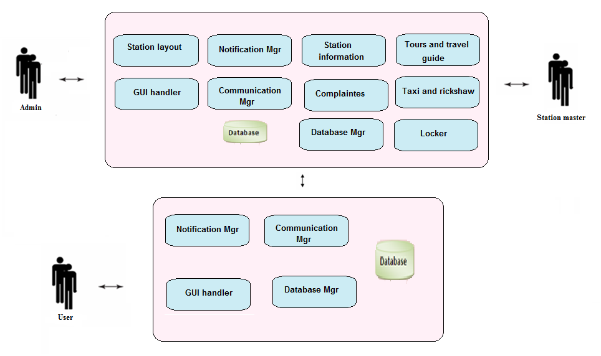
- Conclusion and Future work
This application can help the passenger to get all the information needed for instance information about platform, train, station layout, information about nearest tourist places, locker, etc
This is very user friendly application to be made in android and java technology.
It offers a helping hand to the passengers in order to travel safely with efficient knowledge about new trains and its platform.
Future scope of our application is that it will help the passenger with reservation of seats. The booking can be done online with online payment facility. It will provide PNR status, upgrade the seats and inform about the arrivals and departures of the train.
Our application will provide facility of checking the booking number of the train booking.
The application will be available on web and on desktop. If the transportation is prepaid then payment portal will be needed,

Fig 1: Application system overview of Rail Commute
Referances
[1]Raman, K.S. and Wig, S., ASCI Journal of Management, 2010, vol 39, page 33-54.
[2] Agarwal S., Singhal R., Mittal R., Freight Operations Information System (FOIS) – advanced architecture & its Future. IJLRST 2013, Vol 2 Issue 2.
[3] Agarwal, V.K., Indian Railways in Full steam, www.pib.nic.in
[4] CRIS Projects: passenger r http://cris.org.in/CRIS/Projects/PRS eservation system,
[5] Kumar, A., Gadgil, A., Satapathy, A., Upadhyayula, R., Prabhudesai, S., Indian Railways IT Interface, IIMA Research and Publications, 2001.
[6] Design Document for PRS-CMC-CRIS
[7] CMC Ltd (2013). ‘Reservation system for IndianRailways, http://www.cmcltd.com/industry_practices/transportation/reservation_system_indian_railways.htm
[8] Agarwal S., Rake management system: operational aspect of freight operating system, IJECS 2013, vol 2, Issue 5.
[9] Railway Audit Report, Chapter 1Computerized Passenger Reservation System of the Indian Railways, Report No 11 of 2007.
[10] http://borjournals.com/Research_papers/Jun_2013/1356IT.pdf

